Project Proposal

CAD Claud

Leszek Dubicki, x14125439, Leszek.dubicki@student.ncirl.ie

Higher Diploma in Cloud Computing

21 June 2015

1. Objectives

The project aimes to create cloud based information sharing service for cad and engineering applications. It’s purpose is to create platform and initial components for sharing engineering information between applications typically used in engineering enterprise. It will also include API to allow to connect new components.

The project will include special embedded CAD features/plugins (for FreeCAD and for Solidworks) interacting with cloud based application calculating shaft loads and shaft deformations based on information from connected CAD client. The application will also be able to send data to clients requesting them.

Data that will be shared include text and numerical values (to be stored as global variables or custom properties in CAD files) and basic 2D geometry (points, lines, arcs and circles) stored as sketches or curves in CAD files. This data will be either synchronized with connected cloud service or will be inserted only on user request.

1. Background

Currently working with modern CAD systems means working with files of their native file format stored in version control environment usually supplied by the same software vendor. An examples would be Solidworks and EPDM or Creo Parametric and Windchill. Data sharing across multiple files is usually achieved by creating external references to other native files or by linking to other popular format files, usually excel.

CAD systems like Solidworks or CATIA or Creo Parametric are very powerfull modelling tools but also very expensive systems. There are also free alternatives, usually with less capabilities than commercial systems. Having cloud based platform to share cad data creates opportunity to adopt both commercial and open software and have engineering teams working and cooperating in one environment without a need to purchase large quantities of very expensive licenses.

Other possible use of such platform would be connecting CAD applications to ERP systems. Such systems exist at the moment but require purchasing additional licenses (for example Solidworks ToolWorks ERP-Link or SOLIDWORKS® Enterprise PDM integration for ERP).

1. Technical Approach

Components will be deployed to PythonAnywhare cloud service. They will include component for calculations, web application for user interface, component for interacting with the clients. On the client side there will be component for interacting with server component and possibly Windows COM server for interacting with SolidWorks embedded components written in VBA (this technology is the best for embedded macros in Solidworks). Freecad scripted objects will interact directly with client middleware component.

1. Special resources required

Working Solidworks installation – it’s possible to borrow the license, I’ll borrow it from one of my former employers. I will also use my own Pythonanywhare account for deploying the application.

1. Project Plan

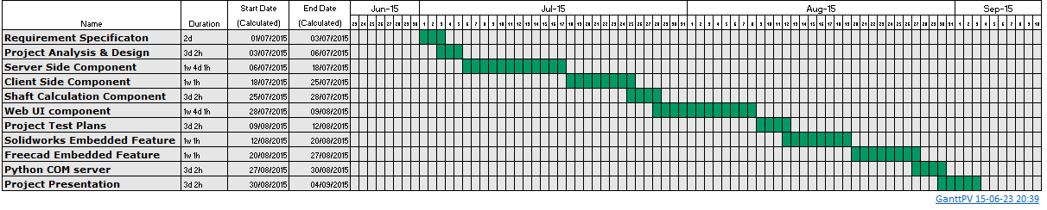

1. Technical Details

All code will be made using Python, except for Solidworks embedded components (Macro Features) which will be made in VBA.

1. Evaluation

System will be evaluated using real life examples from my engineering practice.

Leszek Dubicki

23/06/2015

_____________________

Signature of student and date